Implementation of File Transfer Protocol using Network Simulation Tool

**PROJECT REPORT**

MINI PROJECT (IDS353)

BTech Data Science 3rd Sem.

|  |  |
| --- | --- |
| PROJECT GUIDE:  Er. Ghufran Khan  Sr.Faculty(i-nurture) | SUBMITTED BY:  Manas Chauhan (TCA2166012)  Avi Kumar (TCA2166009)  Ankur Gangwar (TCA2166005) |

23rd September, 2022



**FACULTY OF ENGINEERING & COMPUTING SCIENCES**

**TEERTHANKER MAHAVEER UNIVERSITY**

**MORADABAD**

**DECLARATION**

We hereby declare that this Project Report titled Implementation of File Transfer Protocol using Network Simulation Tool submitted by us and approved by our project guide, Faculty of Engineering & Computing Sciences. Teerthanker Mahaveer University, Moradabad, is a bonafide work undertaken by us and it is not submitted to any other University or Institution for the award of any degree diploma / certificate or published any time before.

|  |  |  |
| --- | --- | --- |
| **Project ID :** | Project Id | |
| **Student Name:** | Manas Chauhan | Signature |
| **Student Name:** | Avi Kumar | Signature |
| **Student Name:** | Ankur Gangwar | Signature |
|  |  |  |
| **Project Guide :** | Er. Ghufran Khan | Signature |

Table of Contents

1 Project Title: 4

2 Domain: Networking 4

3 Problem Statement: 4

4 Project Description: 4

4.1 Scope of the Work: 4

Project Modules: 5

In this Project a basic FTP connection is established from two different networks and FTP server is configured to work from any device in any network 5

Steps to be followed to configure FTP: 5

1.Make a network from which FTP server will be accessed. For this we have created two different networks i.e., 192.168.1.0 & 192.168.2.0, I have taken Class C IP address for simple and better understanding although you can use any Class IP address. 5

2.Attach all the networking devices as your wish. 5

3.Assign IP addresses, Subnet Mask and Default Gateway to all the devices so that we can communicate with them. 5

4.After Implementing RIP we are ready to check the communication of our devices inside as well as outside the network. 5

5.Last step to start configuring the FTP server. 5

5 Implementation Methodology: 5

5.1 FTP Clients: 6

5.2 Why do Businesses use FTP? 6

5.3 How does FTP translate to the real world? 7

5.4 How do you use FTP? 7

6 Technologies to be used: 8

Hardware Platform: 14

7. Advantages of this Project: 15

8. Future Scope and further enhancement of the Project: 15

- Benefits of FTP Servers: 15

1. Security 16

2. Control 16

3. Large File Sizes 16

4. Improved Workflow 16

5. Disaster Recovery 16

9. Team Details: 16

10. Conclusion: 17

**Appendix**

**A: Data Flow Diagram (DFD)**

**B: Entity Relationship Diagram (ERD)**

**C: Use Case Diagram (UCD)**

**D: Data Dictionary (DD)**

**E: Screen Shots**

# Project Title:

**Implementation of File Transfer Protocol using Network Simulation tool**

# Domain: Networking

# Problem Statement:

1) To promote sharing of files (computer programs or data).

2) To encourage indirect or implicit (via programs) use of remote computers.

3) To shield a user from variations in file storage systems among hosts.

4) To transfer data reliably and efficiently.

# Project Description:

The term file transfer protocol (FTP) refers to a process that involves the transfer of files between devices over a network. The process works when one party allows another to send or receive files over the Internet.

## Scope of the Work:

FTP servers are the solutions used to facilitate file transfers across the internet. If you send files using FTP, files are either uploaded or downloaded to the FTP server. When you're uploading files, the files are transferred from a personal computer to the server.

## Project Modules:

## In this Project a basic FTP connection is established from two different networks and FTP server is configured to work from any device in any network

# Steps to be followed to configure FTP:

# 1.Make a network from which FTP server will be accessed. For this we have created two different networks i.e., 192.168.1.0 & 192.168.2.0, I have taken Class C IP address for simple and better understanding although you can use any Class IP address.

# 2.Attach all the networking devices as your wish.

# 3.Assign IP addresses, Subnet Mask and Default Gateway to all the devices so that we can communicate with them.

# 4.After Implementing RIP we are ready to check the communication of our devices inside as well as outside the network.

# 5.Last step to start configuring the FTP server.

# Implementation Methodology:

FTP stands for File Transfer Protocol which is a network transmission standard that uses TCP.

FTP allows files or data to transfer between two computers over an internet connection.

TCP, or Transmission Control Protocol, is what makes FTP reliable; checking and ensuring that your data actually arrives at its destination.

An FTP server and FTP client relationship uses the file transfer protocol to facilitate communications.

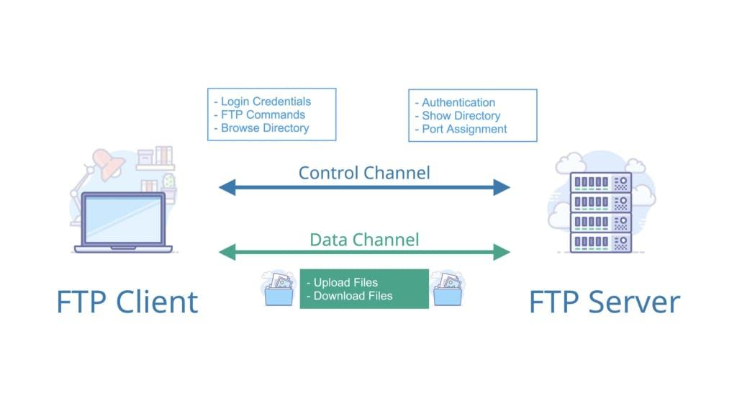

### FTP Clients:

An FTP client is software you use to manage your interactions with an FTP server.

The FTP client will translate your interactions into commands that are sent to the FTP server.

File transfer wasn’t always this easy. Before drag and drop or FTP clients, FTP actually began by typing commands into a terminal window. Which can still be done today.

There are a lot of commands you can learn that are powerful. But most likely you’ll use an FTP client and never have to type any commands at all.

## Why do Businesses use FTP?

Let’s look at [why businesses use FTP](https://www.exavault.com/product/ftp-solution) and why it can be vital to a successful business operation.

Some businesses use FTP for critical operations, such as files that need to be exchanged on a routine basis.

FTP is perfect for large file uploads and bulk file transfers that are otherwise impossible with email and some popular file sharing programs.

Another benefit for business is that FTP is the quickest and easiest way to transfer files and images.

## How does FTP translate to the real world?

Engineers, architects, project managers and contractors that work with large files use FTP for smooth and simple file transfer between many stakeholders.

FTP also helps with granular permissions to meet core requirements of compliance between accountants, bookkeepers, CPAs, CFOs and business owners.

There are unlimited uses which is what makes FTP so versatile and powerful.

## How do you use FTP?

Are you ready to check out FTP for yourself?

There are hundreds of [FTP clients](https://www.exavault.com/docs/desktop-ftp-clients) to choose from depending on if you use Mac, Windows, Linux, or another platform.

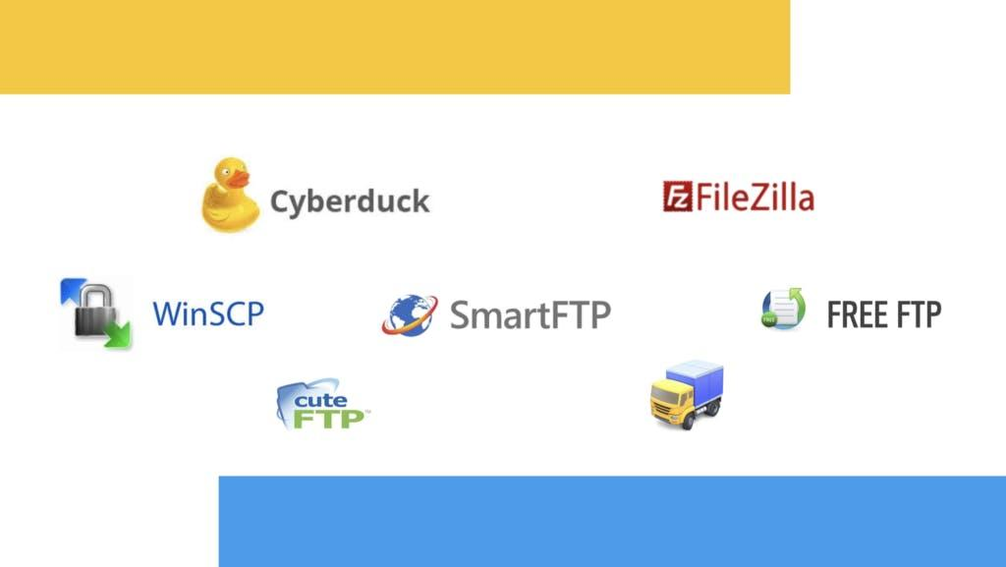

You simply go to their website, download and install the FTP client you have chosen.

[Establish a connection](https://www.exavault.com/docs/generic-desktop-ftp-instructions) by entering the address for the FTP Server you want to connect to, along with your username and password.

Then proceed to upload and transfer files once you have access to the folder structure of the FTP site.

# Technologies to be used:

1. Anonymous FTP. This is the most basic form of FTP.
2. Password-protected FTP. This is also a basic FTP service, but it requires the use of a username and password, though the service might not be encrypted or secure.
3. FTP Secure (FTPS).

**Platform:**

**Cisco packet tracer:**

Cisco Packet Tracer, a visualization and simulation software tool could be accessed for free by Cisco to students registered in a network academy program but could still be used by those outside the academy for educational purposes (Liang Xu Sun, Jian sheng Wu, Yujun Zhang, & Hang Yin, 2013). Packet Tracer is at times utilized as a part of substitute for utilizing genuine equipment (Holvikivi, 2012). This because it utilizes insignificant equipment assets, keeps running on an assortment of stages and is extrembly savvy (Frezzo, Behrens, & Mis levy, 2010). Cisco Packet Tracer has a variety of preferences over the utilization of physical gear. It is simpler to introduce and utilization of it which basically costs nothing rather than physical gear that costs thousands (Makasiranondh, Maj, & Veal, 2010). Also, dissimilar to customary network test systems, Packet Tracer's representation highlights and recreation mode extraordinarily helps students outwardly observe the packet development through the network and this seemingly prompts enhanced learning (Herbert & Wigley, 2015). Thirdly, not at all like physical gear, Packet Tracer requires minimum measures of disk space and Random Access Memory (RAM) since it is just emulating the real environment where no real packet transmission is happening (Gil et al., 2015). Fourthly, on the grounds that Packet Tracer does not really utilize any physical network gadgets, there is no danger of harm or interruption striking the network (Frezzo et al., 2010). Fifthly, Packet Tracer additionally gives the tools to enable teachers to set apappraisals, assignments, tests and exercises. Likewise, it is conceivable to utilize Packet Tracer for group tasks (Javid, 2014).

**Overview of Computer Networking Simulation:**

Network simulator provides network visualization to students. As such, it can be used to enhance and improve the practical knowledge of computer networking principles among students (Anisette et al., 2007). Moreover, students can design mini projects with solutions with more innovation and creativity. As with other tools, students are Cisco Packet Tracer Simulation as Effective Pedagogy in Computer Networking Course able to understand the use of different networking protocols but they are not able to understand the application of these protocols in the real networks, thus packet tracer can be used to design and configure a network, and understand the application of various protocols (Nawaz, 2013). As students hardly access some different real networking devices, because of a cost and technical issues, movement of packets from source to destination cannot be seen in a real time, thus by using network simulator, students can access the virtual network devices any time and no damage can be caused to devices, moreover the movement of packets can be shown by simulations (Sarkar, 2005).

**Switch:**

First, let's talk about the function an [Ethernet switch](https://www.cdw.com/search/networking/switches/ethernet-switches/?w=RJ1) performs on your network. This type of switch is also referred to as a network switch. It works as a central place for computers, printers and every other wired network device on the network to communicate with each other. The Ethernet switch can also be wired to the [router](https://www.cdw.com/search/networking/routers/?w=RG) via a cable that plugs into an Ethernet port, which allows you to access the internet through the modem.

While some routers are manufactured as a network switch and router combo, a router on its own performs a separate function from the switch even though sometimes they are found in a single device. For a modular setup, the switch, hub and router will all be separate devices on the local network.

**Route:**

There are several types of routers, but most routers pass data between [LANs (local area networks)](https://www.cloudflare.com/learning/network-layer/what-is-a-lan/) and [WANs (wide area networks)](https://www.cloudflare.com/learning/network-layer/what-is-a-wan/). A LAN is a group of connected devices restricted to a specific geographic area. A LAN usually requires a single router.

A WAN, by contrast, is a large network spread out over a vast geographic area. Large organizations and companies that operate in multiple locations across the country, for instance, will need separate LANs for each location, which then connect to the other LANs to form a WAN. Because a WAN is distributed over a large area, it often necessitates multiple routers and switches*.

\**A*[*network switch*](https://www.cloudflare.com/learning/network-layer/what-is-a-network-switch/)*forwards data packets between groups of devices in the same network, whereas a router forwards data between different networks.*

Think of a router as an air traffic controller and data packets as aircraft headed to different airports (or networks). Just as each plane has a unique destination and follows a unique route, each packet needs to be guided to its destination as efficiently as possible. In the same way that an air traffic controller ensures that planes reach their destinations without getting lost or suffering a major disruption along the way, a router helps direct data packets to their destination IP address.

In order to direct packets effectively, a router uses an internal routing table — a list of paths to various network destinations. The router reads a packet's header to determine where it is going, then consults the routing table to figure out the most efficient path to that destination. It then forwards the packet to the next network in the path.

To learn more about [IP](https://www.cloudflare.com/learning/network-layer/internet-protocol/) routing and the protocols that are used during this process, read [What is routing?](https://www.cloudflare.com/learning/network-layer/what-is-routing/)

Although some Internet service providers (ISPs) may combine a router and a modem within a single device, they are not the same. Each plays a different but equally important role in connecting networks to each other and to the Internet.

A router forms networks and manages the flow of data within and between those networks, while a modem connects those networks to the Internet. Modems forge a connection to the Internet by converting signals from an ISP into a digital signal that can be interpreted by any connected device. A single device may plug into a modem in order to connect to the Internet; alternately, a router can help distribute this signal to multiple devices within an established network, allowing all of them to connect to the Internet simultaneously.

Think of it like this: If Bob has a router, but no modem, he will be able to create a LAN and send data between the devices on that network. However, he will not be able to connect that network to the Internet. Alice, on the other hand, has a modem, but no router. She will be able to connect a single device to the Internet (for example, her work laptop), but cannot distribute that Internet connection to multiple devices (say, her laptop and her smartphone). Carol, meanwhile, has a router and a modem. Using both devices, she can form a LAN with her desktop computer, tablet, and smartphone and connect them all to the Internet at the same time.

**Research Importance and Limitation:**

The research given a good direction in accessing the effectiveness of Cisco Packet Tracer utilization in Computer Networking subject. The Cisco Packet Tracer allows students to build self-contained computer networks as well as implement all necessary configurations such as placing physical wire connections, setting IP addresses and simulating data transmission simulations. Generally, Cisco is a renowned company which giving training, teaching and learning and certification of Computer Networks commercially. Using the Packet Tracer, the students will gain the experience of using the software and hardware base from Cisco without the need for registration and attendance to training which is apparently costly for them. The research is conducted in UPSI and focusing to the undergraduates registered for subject Computer Networking (MTN3023) in semester 2 session 2016/2017 (A162) as the participants. At the meantime, the Cisco Packet Tracer is the only network simulation being used throughout the research.

**Results and Discussion**:

In this section the students’ perception and feedback on TCP/IP Network particularly on the layering concept is shown. Figure 2 shows that majority of the students (N=44, 80%) accepted the facts the layering concept is hard to conceptualize and imagined. This is concurred to some of the previous research findings for instance by Huang. iJIM ‒ Vol. 13, No. 10, 2019 9 Paper—Cisco Packet Tracer Simulation as Effective Pedagogy in Computer Networking Course Nevertheless, after being exposed to Cisco packet Tracer, students gained valuable insight and feel more comfortable in designing and configuring their own Local Area Network (LAN) without worries on the layering abstraction. This situation had been shown in Figure 3 where all students are confidence in creating LAN to the extent that 19 are very confident in their response. Fig. 2. Students’ perception on Computer Network TCP/IP layering abstraction . Fig. 3. Students’ confident in configuring LAN after exposed to Cisco Packet Tracer Students’ critical assessment on Cisco packet Tracer is shown in this section. Figure 4 shows that all students are able to simulate the LAN environment which compromising several key hardware such PC, Notebook, Servers and Switches as being outlined 10 http://www.i-jim.org Paper—Cisco Packet Tracer Simulation as Effective Pedagogy in Computer Networking Course in the previous chapter. They also manage to specify the best and correct connectors (wires) to connect every devices in the LAN. In the survey 35 subject given the response of “Strongly Agree” to the questions which indicated their appreciations on the utilization of Cisco Packet Tracer in the MTN3023 course. Fig. 4. Students’ ability to create LAN using Cisco packet Tracer In LAN configuration and development, students are required to plan the network and one of the important part is to manage the network IP class. Using Cisco Packet Tracer, students were exposed with the configuration of IP address for each node. By that they are bound to know the class of IP and its corresponding network address, subnet mask address and broadcast address. Figure 5 shows that 28 subject are “Strongly Agree” and 24 subjects are “Agree” to the fact that those information are easily specified and understood by Using Cisco packet Tracer. Students also got experience in configuring each nodes IP address using the simulation either by static or dynamic configuration. Figure 6 shows 54 subject are in the group of “Strongly Agree” and “Agree” combined in term of their ability to correctly configured IP address for each node in the simulation. Meanwhile Figure 7 shows all students are in agreement that Cisco Packet Tracer gave them chances to configure IP address in both static and dynamic conditions. iJIM ‒ Vol. 13, No. 10, 2019 11 Paper—Cisco Packet Tracer Simulation as Effective Pedagogy in Computer Networking Course Fig. 5. Students’ ability to specify IP address information using Cisco packet Fig. 6. Students’ ability to configure IP Address for each node in Cisco Packet Tracer 12 http://www.i-jim.org Paper—Cisco Packet Tracer Simulation as Effective Pedagogy in Computer Networking Course Fig. 7. Students’ ability to configure Static and Dynamic IP address in Cisco Packet Tracer One of the main architecture in Computer Networking is client and server environment. By that, it is vital for student to grab the concept on this architecture. Figure 8 gave a strong indication on the effectiveness of Cisco Packet Tracer in simulating the architecture and exhibiting the environment to students. Here, students’ overview on the functionality of servers are shown which depicted all students to concord (27 Strongly Agree and 26 Agree) on Cisco Packet Tracer capability to simulate the server connection and communication to clients. Fig. 8. Students’ overview on servers’ functionality using Cisco Packet Tracer iJIM ‒ Vol. 13, No. 10, 2019 13 Paper—Cisco Packet Tracer Simulation as Effective Pedagogy in Computer Networking Course Finally, students’ overall feedback on the utilization of CISCO packet Tracer as simulating tool in teaching and learning of MTN3023 (Computer Networking) course is depicted by Figure 9. It is clearly shown that all students (34 Strongly Agree and 21 Agree) that CISCO Packet Tracer had help them in their understandings on how computer networks work. Their feedback is truly based on the potentiality of CISCO Packet Tracer in simulating key computer network concept as being explained and shown in the above paragraphs and figures.

## Hardware Platform:

**Minimum Hardware Requirements:**

Surprisingly, a server doesn't necessarily have to be a high specification machine. You could minimally host your FTP with the following:

1. 2GHz or Higher CPU  
   2. 4GB RAM  
   3.100GB Hard Drive

**Memory Considerations:**

It's very important to have enough memory on your server as busy servers will always perform much quicker with plenty of memory. Most of the important application data is usually stored in memory. Therefore, the more memory you have, the more applications you can safely run. If your server starts to run low on memory, it will start to use the hard drive more.

**Hard Drive Performance:**

To add to the above memory considerations, it is worth noting that with a very busy server, the hard drive is often responsible for bad performance. Ensuring a fast Hard Drive (at least 7200RPM) is a key element of your server's hardware configuration.

# 7. Advantages of this Project:

1) Allows the transfer of multiple files and directories

0032Ability to resume a transfer if the connection is lost

1. Ability put items into a queue to be uploaded or downloaded
2. Allows you to schedule transfers
3. No size limitation on single transfers (browsers only allow up to 2 GB)

# 8. Future Scope and further enhancement of the Project:

[FTP servers](https://www.ftptoday.com/blog/things-you-should-know-about-cloud-sftp-servers) can be considered the midpoint between the sender and the recipient of a file. For FTP servers to work, you need the server address. Here’s an example of what this address may look like “ftp.examplecompany.net”. Sometimes, the server address will be given as a numeric address, like “12.345.678.90”.

Depending on the [type of FTP server](https://www.ftptoday.com/ftp-comparison-guide-offer) you use and the level of security that is needed, you may have to input a username and password. Some FTP servers allow for anonymous connection, which does not require you to enter a name or password to gain access.

## Benefits of FTP Servers:

Although FTP is one way to transfer files, there are certainly other options. So, what is the benefit of using FTP over another means of transfer? Here are five [benefits that companies can reap when they use FTP servers](https://www.ftptoday.com/blog/key-advantages-and-disadvantages-of-ftp) as opposed to other transfer options.

### 1. Security

### 2. Control

### 3. Large File Sizes

### 4. Improved Workflow

### 5. Disaster Recovery

# 9. Team Details:

| **Project Name & ID** | **Course Name** | **Student ID** | **Student Name** | **Role** | **Signature** |
| --- | --- | --- | --- | --- | --- |
| IMPLEMENTA--TION OF FILE TRASFER PROTOCOL using Network Simulation tool  (FTP)-IDS353 | MINI PROJECT LAB | TCA2166012 | Manas Chauhan | Representative |  |
| TCA2166009 | Avi Kumar | Developer |  |
| TCA2166005 | Ankur Gangwar | Second Developer |  |

# 10. Conclusion:

FTP is a very useful software application that can have enormous benefit to a Web site or to collaborative computing in which files need to be shared between business partners. Although insecure, it is universally accessible, because FTP clients are a part of all operating systems and Web browsers. The CISCO Packet Tracer deployment in the course and students’ feedback on its utilization is based on the objectives which had been outlined in the related section. Each objective and the explanation on its fulfilment are reported as the following: Objective 1: To examine the impact of Cisco Packet Tracer as simulation in practical session of the Computer Networking subject The CISCO Packet Tracer had been deployed and utilize in the MTN3023 Computer Networking subject as a simulation tool. Based on the subjects’ feedback which exhibited in Chapter 4 they had gained experience and confidence to configure Local Area Network (LAN) after being exposed to CISCO Packet Tracer. As such, the CISCO Packet Tracer had been discovered of putting a positive impact on students’ understanding and tendency towards the course. Objective 2: To analyse students understanding of TCP/IP network based on network that develop and configured using Cisco Packet Tracer Students had given a very positive and good feedback on how CISCO Packet Tracer enhanced their understanding of TCP/IP network. The simulation helps to ease the abstraction of TCP/IP layering framework which always be an obstacles in TCP/IP understanding among students. Moreover using CSICO Packet Tracer students were able to configured basic TCP/IP settings such as IP address configuration, connections and The CISCO Packet Tracer deployment in the course and students’ feedback on its utilization is based on the objectives which had been outlined in the related section. Each objective and the explanation on its fulfilment are reported as the following: Objective 1: To examine the impact of Cisco Packet Tracer as simulation in practical session of the Computer Networking subject The CISCO Packet Tracer had been deployed and utilize in the MTN3023 Computer Networking subject as a simulation tool. Based on the subjects’ feedback which exhibited in Chapter 4 they had gained experience and confidence to configure Local Area Network (LAN) after being exposed to CISCO Packet Tracer. As such, the CISCO Packet Tracer had been discovered of putting a positive impact on students understanding and tendency towards the course. Objective 2: To analyze students understanding of TCP/IP network based on network that develop and configured using Cisco Packet Tracer Students had given a very positive and good feedback on how CISCO Packet Tracer enhanced their understanding of TCP/IP network. The simulation helps to ease the abstraction of TCP/IP layering framework which always be an obstacles in TCP/IP understanding among students. More over using CSICO Packet Tracer students were able to configured basic TCP/IP settings such as IP address configuration, connections and 14 http://www.i-jim.org Paper—Cisco Packet Tracer Simulation as Effective Pedagogy in Computer Networking Course server configuration. On top of that, students also exposed to client –server environment which could be easily simulated using CISCO Packet Tracer. By understanding the client-server environment alone had benefitted students in a very large view as the framework is forming a vast aspect of TCP/IP network. Objective 3: To investigate the effectiveness of CISCO Packet Tracer in teaching and learning of Computer Networking subject One of the hardest things in Computer Networking teaching and learning is to simulate the real world network without an appropriate hardware (which is costly to buy). By using CISCO packet Tracer simulation tool the challenge had been smoothen and students had a big opportunity to simulate real world network easily and effectively. This had been proven by a feedback by students who sense that they are more confident configuring LAN after using the simulation. They also feel that their understanding on the TCP/IP network had been better than before. Moreover, the CISCO Packet Tracer allows them to configure each nodes (PC, Servers etc.) which give them opportunity to explore and dictate the network development with their own wisdom. Finally, based on students’ overall feedback the effectiveness of CISCO Packet Tracer is ever-essential in assisting them to master the computer network course. Overall, the CISCO Packet Tracer had been successfully deployed as a simulation tool in Computer Networking course and the students’ feedback is enormous. Its help to support the practical part of the course with a minimal cost. On top of that, the simulation also seen as stepping stone for the students to go for professional CISCO certification as by using CISCO Packet Tracer they were actually working with real CISCO hardware. Moving forward the CISCO Packet Tracer should be used to support the lecture materials on which the top-down approach in Computer Networks teaching and learning had been employed in University Pendidikan Sultan Idris. The network layer abstraction must be look into and investigated in deeper manner. Then, The CISCIO Packet Tracer could be used to simulate the main layer abstraction by which students’ understanding on the abstraction is answered server configuration. On top of that, students also exposed to client –server environment which could be easily simulated using CISCO Packet Tracer. By understanding the client-server environment alone had benefitted students in a very large view as the framework is forming a vast aspect of TCP/IP network. Objective 3: To investigate the effectiveness of CISCO Packet Tracer in teaching and learning of Computer Networking subject One of the hardest things in Computer Networking teaching and learning is to simulate the real world network without an appropriate hardware (which is costly to buy). By using CISCO packet Tracer simulation tool the challenge had been smoothen and students had a big opportunity to simulate real world network easily and effectively. This had been proven by a feedback by students who sense that they are more confident configuring LAN after using the simulation. They also feel that their understanding on the TCP/IP network had been better than before. Moreover, the CISCO Packet Tracer allows them to configure each nodes (PC, Servers etc.) which give them opportunity to explore and dictate the network development with their own wisdom. Finally, based on students’ overall feedback the effectiveness of CISCO Packet Tracer is ever-essential in assisting them to master the computer network course. Overall, the CISCO Packet Tracer had been successfully deployed as a simulation tool in Computer Networking course and the students’ feedback is enormous. Its help to support the practical part of the course with a minimal cost. On top of that, the simulation also seen as stepping stone for the students to go for professional CISCO certification as by using CISCO Packet Tracer they were actually working with real CISCO hardware. Moving forward the CISCO Packet Tracer should be used to support the lecture materials on which the top-down approach in Computer Networks teaching and learning had been employed in University Pendidikan Sultan Idris. The network layer abstraction must be look into and investigated in deeper manner. Then, The CISCIO Packet Tracer could be used to simulate the main layer abstraction by which students’ understanding on the abstraction is answered.

**11. References:**

FTP, or file transfer protocol, has been around since the 1990’s. It’s a way to transfer files to any computer in the world that is connected to the internet, which is a Wide Area Network (WAN). File servers, in contrast, are only accessible within a business’ internal network, part of a Local Area Network (LAN). To put it simply, WANs are public; LANs, are closed. They essentially act as a shared hard drive for businesses. [3] Anisette, M., Beland, V., Colombo, A., Cremini, M., Damiani, E., Frat, F., Rebecame, [4] D. (2007). Learning computer networking on open paravirtual laboratories. IEEE Transictions on Education, 50(4), 302–311. [5] Anuzelli, G., Dynamics, A., Dingane, A., Gnus, I., Images, I. O. S., Utilization, R., Emulated, H. C. (n.d.). GNS3 Documentation. Retrieved November 28, 2017, from https://docs .gns3.com/ [6] Furazan. (2000). Data Communications and Networking (2nd ed.). McGraw-Hill. [7] Chang, R. K. C., C., R. K., Chang, & C., R. K. (2004). Teaching computer networking with the help of personal computer networks. ACM SIGCSE Bulletin, 36(3), 208. https://doi.org/10.1145/1026487.1008052 [8] Cisco Networking Academy. (2015). Cisco Networking Academy. 2015. [9] Cisco Systems. (2017). Cisco Networking Academy. Retrieved from https://www.netacad.com/courses/packet-tracer-download/ [10] Coffman, T. (2006). Using Simulations to Enhance Teaching and Learning. Virginia Soc. Technol. Educ. J, 21(2), 1–6. [11] Bertsekas and R. Gallage. (1992). Data Networks (2nd ed.). Prentice-Hall. [12] Frezzo, D. C., Behrens, J. T., & Mislevy, R. J. (2010). Design patterns for learning and assessment: Facilitating the introduction of a complex simulation-based learning environment into a community of instructors. Journal of Science Education and Technology, 19(2), 105–114. https://doi.org/10.1007/s10956-009-9192-0 [13] Gil, P., Garcia, G. J., Delgado, A., Medina, R. M., Calderon, A., & Marti, P. (2015). Computer networks virtualization with GNS3: Evaluating a solution to optimize resources and achieve distance learning. In Proceedings - Frontiers in Education Conference, FIE (Vol. 2015–Febru, pp. 1–4). IEEE. https://doi.org/10.1109/fie.2014.7044343 [14] Herbert, B. M., & Wigley, G. B. (2015). The Role of Cisco Virtual Internet Routing Lab in network training environments. Julio. [15] Holvikivi, J. (2012). From Theory to Practice: Adapting the Engineering Approach. In Conference on Engineering Education 2012 (p. 78). [16] Issariyakul, T., & Hossain, E. (2011). Introduction to network simulator NS2. Springer Science & Business Media. [17] Janitor, J., Jakab, F., & Kniewald, K. (2010). Visual learning tools for teaching/learning computer networks: Cisco Networking Academy and Packet Tracer. In Networking and Services (ICNS), 2010 Sixth International Conference on (pp. 351–355). IEEE. https://doi.org/10.1109/icns.2010.55 [18] Javid, S. R. (2014). Role of Packet Tracer in learning Computer Networks. International Journal of Advanced Research in Computer and Communication Engineering, 3(5), 6508– 6511. [19] Kainz, O., Cymbalak, D., Lamer, J., Michalko, M., & Jakab, F. (2016). Innovative methodology and implementation of simulation exercises to the Computer networks courses. In ICETA 2015 - 13th IEEE International Conference on Emerging eLearning Technologies and Applications, Proceedings (pp. 1–6). IEEE. https://doi.org/10.1109/iceta.2015.7558481 [20] Kurose, J. F., & Ross, K. W. (2017). Computer networking: a top-down approach. Pearson (7th ed., Vol. 7). Essex: Pearson Education Limited. [21] L. Peterson and B. Davie. (2000). Computer Networks: A Systems Approach (2nd ed.). Morgan Kaufmann. [22] Liangxu Sun, Jiansheng Wu, Yujun Zhang, & Hang Yin. (2013). Comparison between physical devices and simulator software for Cisco network technology teaching. In 2013 8th International Conference on Computer Science & Education (pp. 1357–1360). IEEE. https://doi.org/10.1109/iccse.2013.6554134

**Annexure A**

**Data Flow Diagram (DFD)**

**(Mandatory)**

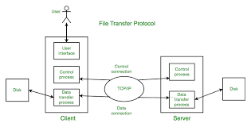

**Annexure B**

**Entity-Relationship Diagram (ERD)**

**(Mandatory)**

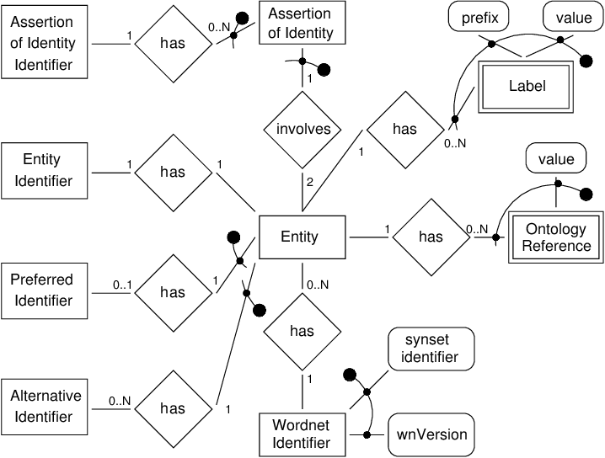

**Annexure C**

**Use-Case Diagram (UCD)**

**(Optional)**

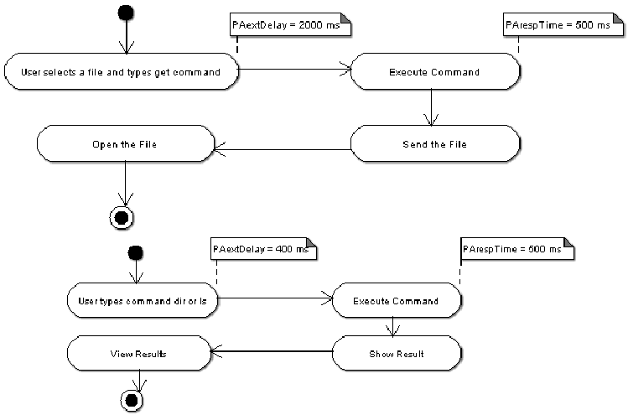

**Annexure E**

**Screen Shots**

**Home Page:**

